How to get feedback on your project idea
Interreg Europe joint secretariat can give you feedback on your project idea. Just a few steps to get our assistance.

- Check the fit of your project idea
- Is your project idea relevant to Interreg Europe? Check at: http://www.interregeurope.eu/self-assessment/
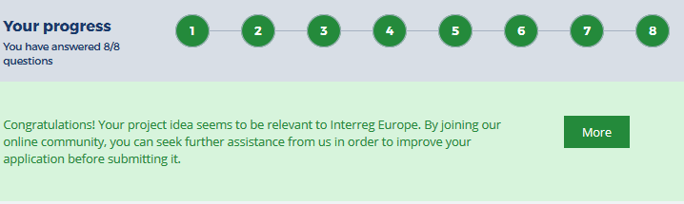
For inspiration, check already approved projects at: http://www.interregeurope.eu/discover-projects/
- Join Interreg Europe community
- Register your profile in our community or log in to your account at http://www.interregeurope.eu/
Add information about your institution and a picture to your personal profile to attract potential project partners.
- Add your project idea to Interreg Europe database
- Describe your project idea for potential project partners and make it public to start your partner search
This information is visible to our website users.
- Add extra information on your project idea
For feedback on your project idea, additional information is required. It is visible only to the joint secretariat.
- Click on ‘Ask for detailed feedback’ and fill in additional information about your project, giving more detail on:
  - the policy instruments addressed
  - involved partners
  - planned activities, etc.
The more detail you provide, the better can our staff understand your project idea and assist you in developing it into a successful application.
- Request feedback on your project idea
- Submit the extended version of your project idea and select the format of feedback you’d like to get:
  - in writing
  - via Skype or phone
Our assistance works on ‘First-come-first-served’ basis.
A project idea can get feedback only once during the call.

We will get back to you as long as our capacity allows.

